华东地区几何拓扑学研讨会日程表

（上海，复旦大学， 2019）

**2019**年**3**月**15**日

报到并入住宝隆宾馆（虹口区逸仙路180号）

18：00-20：00 晚餐

**2019**年**3**月**16**日 会议地点：光华楼东主楼1501室

上午 主持人：吕志

10：00--10：50 刘毅

题目：Sageev construction of cube complexes I

11：10--12：00 刘毅

题目：Sageev construction of cube complexes II

12：00 --14：00 午餐

下午 主持人： 张强

14：30--15：20 程志云

题目：Knot Theory — From Classical to Virtual

15：40--16：30 张影

题目：Trigonometry in hyperbolic 4-space I

16：50--17：40 张影

题目：Trigonometry in hyperbolic 4-space II

18：00 --20：00 晚餐

**2019年3月17日** 会议地点： 光华楼东主楼1501室

上午 主持人 ： 高红铸

9：00--9：50 苏阳

题目： 高维流形的拓扑学简介 I

10：10--11：00 苏阳

题目：高维流形的拓扑学简介 II

11：00 --13：00 午餐

下午 主持人 ： 于立

13：30--14：20 吴建春

题目：A brief introduction to limit groups

14：40--15：30 王宏玉

题目：On Signed Euler Characteristic Classes

15：50--16：40 邱瑞锋

题目：On unknotting numbers of composite knots

17：00 --19：00 晚餐

**2019年3月18日自由讨论及离会**

**摘要：**

程志云 （北京师范大学）

Title: Knot Theory — From Classical to Virtual

Abstract: As an extension of classical knot theory, virtual knot theory was proposed by L. Kauffman in the end of last century. During the past twenty years, many powerful virtual knot invariants have been introduced and intensively studied. Besides of classical knots, virtual knots also have close connections with some other types of knots, such as abstract knots, welded knots, free knots and knotoids. In this talk, I will give a brief introduction to virtual knot theory and discuss some virtual knot invariants derived from chord index. Some part of this talk is based on a joint work with Hongzhu Gao and Mengjian Xu.

刘毅 （北京数学中心）

Title: Sageev construction of cube complexes

Abstract: The so-called Sageev construction is widely used for producing actions of a group on cube complexes. In particular, it is applied as the first step of Agol's proof of the Virtual Haken Conjecture. In this mini-course, I will explain the basic idea of the construction, and discuss briefly how it is used in Agol's proof.

邱瑞锋 （华东师范大学）

Title: On unknotting numbers of composite knots

Abstract：In this talk, I will introduce a possible way to determine the unknotting number of the connected sum of two knots.

苏阳 （中科院）

题目：高维流形的拓扑学简介

摘要：在这个短课中我将简要介绍高维流形拓扑研究中的一些基本问题与结果，包括：作为基础的h与s配边定理，和拟同痕定理；它们的一些简单应用；纤维化定理与分裂定理；流形分类的基本定理。这里一般的模式是通过surgery将关心的几何问题转化到可以应用s配边定理的情形，这中间产证来自于同伦论和代数K理论和L理论的阻碍。

王宏玉 （扬州大学）

Title： On Signed Euler Characteristic Classes

Abstract：Let $M$ be a closed symplectic manifold of dimension $2n$ with non-ellipticity. We can define an almost Kahler structure on $M$ by using the given symplectic form. Hence, we have a $\gamma = \pi_1(M)$- invariant almost Kahler structure on the universal covering of $M$. Using Darboux coordinate charts, we deform the given almost Kahler structure on the universal covering of $M$ to obtain a  $\gamma$-Lipschitz Kahler structure on the universal covering of $M$ which is  $\gamma$-homotopy equivalent to the given almost Kahler structure. Analogue to Teleman's $L^2$ Hodge decomposition on PL manifolds or Lipschitz Riemann manifolds, we give a $L^2$ Hodge decomposition theorem on the universal covering of $M$ with respect to the Lipschitz Kahler metric. Using an argument of Gromov, we give a vanishing theorem for $L^2$ harmonic p-forms, $p \neq n$ (resp. a non-vanishing theorem for $L^2$ harmonic n-forms) on the universal covering of $M$, then its signed Euler characteristic satisfies $(-1)^n \Gamma(M) \meq 0$ (resp. $(-1)^n\Gamma(M) > 0$). As an application, we show that the Chern-Hopf conjecture holds true in closed even dimensional Riemannan manifolds with nonpositive curvature (resp. strictly negative curvature), it gives a positive answer to a Yau's problem due to S.S. Chern and H. Hopf.

吴建春（苏州大学）,

Title: A brief introduction to limit groups

Abstract：Limit groups are introduced by Z. Sela in his first paper of his solution of Tarski’s problem. These groups are coinciding with the long studied class of finitely generated fully residually free groups. In this talk we will introduce both of them with different points of view and some research topics involved.

张影（苏州大学）

Title: Trigonometry in hyperbolic 4-space

Abstract：We study the geometry of right-angled hexagons in the hyperbolic 4-space $H^4$ via Clifford numbers or quaternions. We show how to augment alternate sides of such a hexagon and arbitrarily orient each line and plane involved, so that for the non-augmented sides, we can define quaternion half side-lengths whose angular parts are obtained from half the Euler angles associated to a certain orientation-preserving isometry of the Euclidean 3-space. We also define appropriate complex half side-lengths for the augmented sides of the augmented hexagon. We further explain how to geometrically read off the quaternion half side lengths for a given oriented, augmented, right-angled hexagon in $H^4$. Our main result is a set of generalized Delambre–Gauss formulas for oriented, augmented, right-angled hexagons in $H^4$, involving the quaternion half side-lengths and the complex half side-lengths. These formulas generalize the classical Delambre–Gauss formulas for spherical/hyperbolic triangles. This is a joint work with Ser Peow Tan and Yan Loi Wong.

**附录：**

**上海宝隆宾馆（虹口区逸仙路180号）到复旦大学光华楼路线:**

1. **打车直接到复旦大学国定路东门**
2. **公交850路（宝隆宾馆，步行360米，公交850路逸仙路纪念路站上车，三站后国定路邯郸路站下车，步行280米到复旦大学光华楼）**

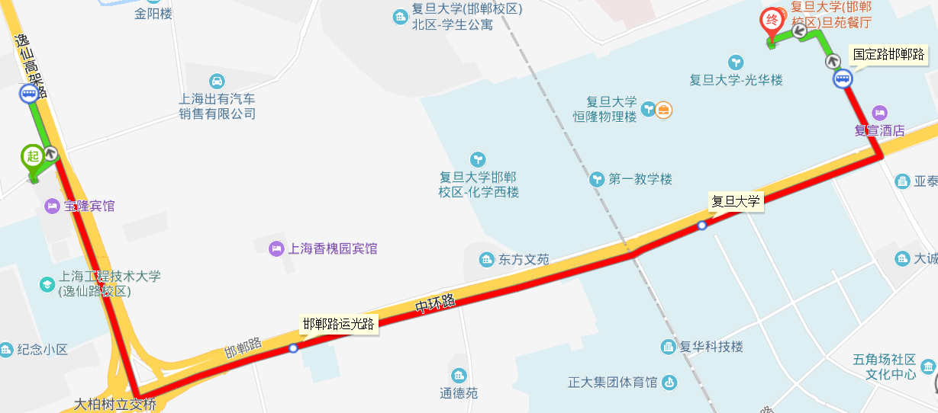

1. **公交812路（宝隆宾馆，步行360米，公交850路逸仙路纪念路站上车，两站后复旦大学站下车， 步行520米到复旦大学光华楼）**

